# Peoplesafe - Viewing the Client Financials Screen

Accessing the Client Financials Screen in PeopleSafe

Client Financials Screen Layout

1 Prescription Information section (top of the screen):

2 Participant Pay section 1st column, labeled with #2:

Health Reimbursement Account

Med D Financials

3 Client Pay section (2nd column labeled #3):

4 Pharmacy Pay (3rd column labeled #4):

Related Documents

**Description:** Details regarding the Client Financials screen. It displays the payment breakdown for each adjudicated (processed) prescription claim. The information on this screen can be helpful when explaining the member’s cost for the prescription and how the prescription cost was applied toward the member’s accumulators (if any).

|  |
| --- |
| Accessing the Client Financials Screen in PeopleSafe |

Any prescriptions from a prior PBM or other line of coverage will not reflect in the financial details.

Perform the following steps:

|  |  |  |
| --- | --- | --- |
| **Step** | **Action** | |
| **1** | Access the PeopleSafe Prescription Details screen. | |
| **If accessing Prescription Details from…** | **Select…** |
| Main Screen | Select the **Prescription number** hyperlink. |
| Prescription History | Select the **Prescription number** hyperlink. |
| Account Balance Tab | Click on **Radio button** next to MAB, MOOP or DED, select **View Balance Details** button and then select the Prescription number hyperlink. |
| Test Claim | Select the **blue hyperlink** indicating the price under POS copay or Mail Copay. |
| **2** | On the Prescription Details screen, select the **View Financials** button.    **Result:** The Client Financials screen displays the corresponding prescription financial information. | |

Top of the Document

|  |
| --- |
| Client Financials Screen Layout |

The Client Financials screen displays the financial information for the selected prescription and is comprised of four sections. The information located in these sections are client specific and may vary:

1. Prescription Information (top of screen)
2. Participant Pay (1st column)
3. Client Pay (2nd column)
4. Pharmacy Pay (3rd column)

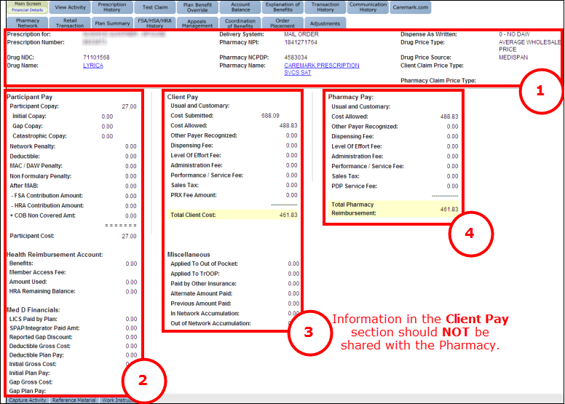

### 1 Prescription Information section (top of the screen):

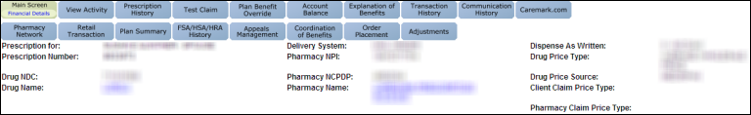

|  |  |
| --- | --- |
| **Field** | **Description** |
| **Prescription for** | Plan member’s name |
| **Prescription Number** | Number identifying the corresponding prescription |
| **Drug NDC** | National Drug Code |
| **Drug Name** | Select this hyperlink to view the corresponding Drug Details screen |
| **Delivery System** | Identifies how the prescription was provided to the member |
| **Pharmacy NPI** | Pharmacy’s National Provider Identifier |
| **Pharmacy NCPDP** | Pharmacy’s National Council for Prescription Drug Programs ID |
| **Pharmacy Name** | Select this hyperlink to view the corresponding Pharmacy Details screen |
| **Dispense as Written** | Refer to [Customer Care Abbreviations, Definitions and Terms Index (017428)](https://thesource.cvshealth.com/nuxeo/thesource/#!/view?docid=c1f1028b-e42c-4b4f-a4cf-cc0b42c91606) |
| **Drug Price Type** | Not used by Customer Care |
| **Drug Price Source** | Not used by Customer Care |
| **Client Claim Price Type / Pharmacy Claim Price Type** | These fields are used to differentiate if there is alternate pricing associated with the claim. Alternate pricing is used for single source generics, which are generics that are awarded exclusive generic status for 6 months after the brand patent has expired. These fields will either be blank or display as “ALTERNATE” when the client/and or pharmacy has elected to use this alternate pricing.  The alternate pricing for a single source generic is generally between the cost of the brand and the generic. It will be used in situations when generic pricing is unavailable. |

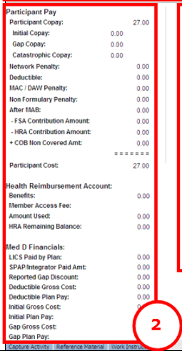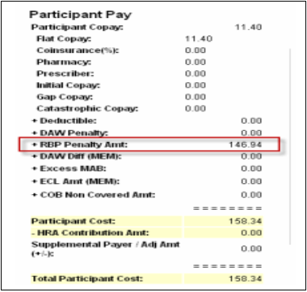

### 2 Participant Pay section 1st column, labeled with #2:

|  |  |
| --- | --- |
| **Field** | **Description** |
| **Participant Copay** | The plan member’s co-payment (Out-of-pocket) amount based on their plan design. |
| **Flat Copay** | Generally, a fixed amount for generic products, and a higher fixed amount for brand-name products.  **Note**: Some plans still have one co‑payment amount for all prescriptions |
| **Coinsurance (%)** | Generally, a fixed percentage amount required to be paid by the member before or after meeting an established policy deductible. May be interchanged with term copay. |
| **Pharmacy** | Portion of the co-payment used to pay the pharmacy dispensing the prescription |
| **Prescriber** | Portion of the co-payment used to pay the prescriber |
| **Initial Copay** | (Med D) Initial co-payment amount based on their plan design prior to Gap or Catastrophic coverage |
| **Gap Copay** | (Med D) Specified amount or percentage a Medicare D beneficiary pays after reaching the initial coverage limit. Refer to CIF. |
| **Catastrophic Copay** | (Med D) Reduced copay amount paid towards prescriptions when a beneficiary has reached the individual TrOOP goal. |
| **Network Penalty** | Client Specific, refer to CIF.  **Note:** When referring to Network Penalty with your caller, refer to it as Network surcharge. |
| **Deductible** | Amount applied (if any) toward the deductible |
| **MAC/DAW Penalty** | Additional amount (as specified in the member’s prescription plan design. See CIF) the member paid for having the prescription filled with a brand medication when a generic was available.  **Note:** The Cost Difference can also be in place for Maintenance Choice Incentivized/network surcharges.  **Note:** When referring to MAC/DAW Penalty with your caller, refer to it as MAC/DAW cost differences. Refer to [Dispense as Written (DAW) Codes (040459)](https://thesource.cvshealth.com/nuxeo/thesource/#!/view?docid=7e5c2587-d679-4b42-b9b1-e98b754c6bff) or [DAW (Dispense as Written) and RBP (Reference Based Pricing) Cost Difference (078542)](https://thesource.cvshealth.com/nuxeo/thesource/#!/view?docid=4c9d2243-5841-45c0-b2ec-805023c6cbcf) |
| **Non-Formulary Penalty** | Applicable Non-Formulary drug rules Copay for medications not on the formulary.  **Note:** When referring to Non-Formulary Penalty with your caller, refer to it as non-Formulary surcharge. |
| **After MAB** | Amount member is responsible for after the Max Allowable Benefit is met |
| **FSA Contribution Amount** | Amount applied to the claim from the members Flexible Spending Account (pre-payroll tax dollars set aside for health-related and medical expenses). |
| **HRA Contribution Amount** | Amount applied to the claim from the members Health Savings Account (Tax-exempt funds provided by the member’s employer) |
| **+ RBP Penalty Amt** | Reference Based Pricing (RBP) was applied. RBP is used when drug classes contain several drugs that are therapeutically similar, but also vary widely in price. A reference price is set for a specific amount, usually the cost of a generic. If a more expensive drug within the class is used, the member may be charged an extra surcharge based on the reference price. This plan design option can vary by client and drug class. Check the CIF and/or Plan Summary screen for more information. Refer to [DAW and RBP Cost Difference](https://thesource.cvshealth.com/nuxeo/thesource/#!/view?docid=4c9d2243-5841-45c0-b2ec-805023c6cbcf) (078542)**Note:** When referencing RBP Penalty amount with the caller, refer to it as a surcharge. |
| **+ DAW Diff (MEM)** | Additional amount (as specified in the member’s prescription plan design. See CIF) the member paid for having the prescription filled with a brand medication when a generic was available  [DAW (Dispense as Written) and RBP (Reference Based Pricing) Cost Difference (078542)](https://thesource.cvshealth.com/nuxeo/thesource/#!/view?docid=4c9d2243-5841-45c0-b2ec-805023c6cbcf) |
| **+ Excess MAB** | Additional amount the member paid because the prescription cost exceeded the Maximum Allowable Benefit |
| **+ ECL Amt (MEM)** | Additional amount the member paid because the prescription exceeded the claim limitation amount |
| **+ COB Non-Covered AMT** | Amount remaining after primary/secondary payment is applied |
| **Participant Cost** | The out-of-pocket portion of the cost of prescriptions that plan members pay through mail order or at retail locations |
| **- HRA Contribution Amt** | The funds contributed towards a paid claim from a members Health Reimbursement Account, if applicable |
| **Supplemental Payer/Adj Amt (+/-)** | The amount paid by the supplemental/secondary plan, seen in EGWP plan adjudication |
| **Participant Cost** | Total amount the member was charged for the prescription |
| Health Reimbursement Account | |
| **Benefits** | Displays amount of HRA funds applied, hyperlinked if the HRA is managed by the PBM and it has HRA dollars from multiple years |
| **Member Access Fee** | Amount of fee attached to utilizing HRA benefits for the claim |
| **Amount Used** | Displays amount of HRA funds applied |
| **HRA Remaining Balance** | Displays the amount remaining of HRA funds, hyperlinked to the member’s account balance details if managed by the PBM |
| Med D Financials | |
| **LICS Paid by Plan** | (Med D) The cost sharing reduction amounts that are applied when a LIS beneficiary fills a script at a pharmacy |
| **SPAP/Integrator Paid Amt** | Not used by Customer Care |
| **Reported Gap Discount** | Displays the gap discount amount paid by the plan |
| **Deductible Gross Cost** | Displays the amount of deductible gross cost applied to the prescription |
| **Deductible Plan Pay** | If the plan includes a deductible this will display the amount paid by the claim adjudicating |
| **Initial Gross Cost** | Initial amount billed by pharmacy |
| **Initial Plan Pay** | Initial amount paid by the plan |
| **Gap Gross Cost** | Amount billed by the pharmacy with the member in the gap before the gap discount is applied |
| **Gap Plan Pay** | Amount the plan pays to create the gap discount |
| **Catastrophic Gross Cost** | Amount billed by the pharmacy before the plan pays |
| **Catastrophic Plan Pay** | Amount the plan plays after being billed to the pharmacy |

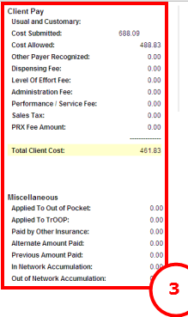

### 3 Client Pay section (2nd column labeled #3):

Icon - Important Information Information in the Client Paysection should **not** be shared with the pharmacy.

|  |  |
| --- | --- |
| **Field** | **Description** |
| **Usual and Customary** | Amount that a pharmacist would charge a cash paying customer or non-plan member for a drug on that day |
| **Cost Submitted** | Cost of the prescription submitted by the pharmacy to adjudicate (process) the claim |
| **Cost Allowed** | Allowed cost of the prescription, as determined by the member’s prescription benefit plan |
| **Other Payer Recognized** | Amount being paid by an additional payer which is not the member or primary insurance |
| **Dispensing Fee** | Amount paid to a pharmacy for distributing each medication in addition to the ingredient cost as determined by the client contract |
| **Level of Effort Fee** | Fee charged by the pharmacy along with the ingredient costs and other charges. The fee is determined by the complexity of decision-making or resources utilized by a pharmacist to perform a professional service. |
| **Administration Fee** | Fee a prescriber charges for injecting or administering a drug |
| **Performance/Service Fee** | Amount paid by the client participating in a performance network pharmacy with certain guarantees of service agreed upon contracting |
| **Sales Tax** | State and local taxes levied on the sale of prescription drugs |
| **PRX Fee Amount** | Amount paid by the client for filing a performance prescription depending on parameters agreed upon during contracting |
| **Total Client Cost** | Total amount the client paid for the prescription |
| **Miscellaneous** | |
| **Applied to Out of Pocket** | Amount of the Rx cost that applied to the member’s out of pocket if the plan design includes one |
| **Applied to TrOOP** | Refer to [Customer Care Abbreviations, Definitions and Terms Index (017428)](https://thesource.cvshealth.com/nuxeo/thesource/#!/view?docid=c1f1028b-e42c-4b4f-a4cf-cc0b42c91606). |
| **Paid by Other Insurance** | Amount adjudicated through Rx claim that was paid by another insurance |
| **Alternate Amount Paid** | Not used by Customer Care |
| **Previous Amount Paid** |
| **In Network Accumulation** |
| **Out of Network Accumulation** |

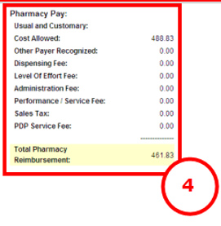

### 4 Pharmacy Pay (3rd column labeled #4):

|  |  |
| --- | --- |
| **Field** | **Description** |
| **Usual and Customary** | Amount that a pharmacist would charge a cash paying customer or non-plan member for a drug on that day. Total cost that the pharmacy submitted for this prescription fill |
| **Cost Allowed** | Disbursement of funds to a Pharmacy for products/services delivered/rendered to a plan member under the drug pricing & reimbursement terms of the Pharmacy Network selected by the Insurer of the plan member. This line is blank for mail order. |
| **Other Payer Recognized** | Not Used by Customer care |
| **Dispensing Fee** | Shows how much the pharmacy requests to be paid to dispense the medication |
| **Level of Effort Fee** | Fee charged by the pharmacy along with the ingredient costs and other charges. The fee is determined by the complexity of decision-making or resources utilized by a pharmacist to perform a professional service. |
| **Administration Fee** | A pharmacy’s charges for injecting or administering a drug |
| **Performance/Service Fee** | Amount paid by the client participating in a performance network pharmacy with certain guarantees of service agreed upon contracting |
| **Sales Tax** | State and local taxes levied on the sale of prescription drugs |
| **Total Pharmacy Reimbursement** | The total amount the pharmacy is reimbursed for dispensing the medication through the member’s plan including the member’s copayment  **Note:** If the pharmacy has a question on this amount, access PeopleSafe and click on the hyperlink for the prescription number. Click on **View Financials** (bottom of screen) then scroll down and click on **View Reimbursements**. Locate Pharmacy Reimbursements and click on the “**+**” symbol to view the claim. Locate the Disbursement Details and view the Total Disbursement amount. |

Top of the Document

|  |
| --- |
| Related Documents |

[Customer Care Abbreviations, Definitions and Terms Index (017428)](https://thesource.cvshealth.com/nuxeo/thesource/#!/view?docid=c1f1028b-e42c-4b4f-a4cf-cc0b42c91606)

**Parent Document:** [CALL 0049 Customer Care Internal and External Call Handling](https://policy.corp.cvscaremark.com/pnp/faces/DocRenderer?documentId=CALL-0049)

Top of the Document

Not to Be Reproduced or Disclosed to Others without Prior Written Approval

**ELECTRONIC DATA = OFFICIAL VERSION / PAPER COPY = INFORMATIONAL ONLY**